Objects may be dragged to a rack if genomes exist for the asset model. Objects may also be dragged on top of existing racked assets for association. The OneView integration also supports auto-association so if the OneView discovered make or model, asset name, IP address, or serial number uniquely matches an existing asset in the open DCO room, then items can be associated with a single button click.

The HP OneView integration tracks blade slot location in blade chassis. When a HP C7000 enclosure is dragged to a rack, or associated to an existing/empty enclosure the

Before association: After Association:
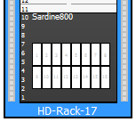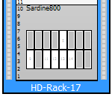

The HP OneView integration will automatically place blades in their proper locations, and it will track changes to blade slots. So if the customer adds, moves, or removes a blade from a chassis, DCO will update accordingly.

The OneView customer experience in DCO is based on the licenses they have purchased for their StruxureWare environment.

- Operations or Colo licenses provide the inventory management features. OneView assets and their details (hostname, serial number, … ).
- Capacity licensing enables visibility of power data for OneView devices which support power monitoring (usually servers and blades). This information is visible in the Power overlay displaying the tooltip for a OneView asset.

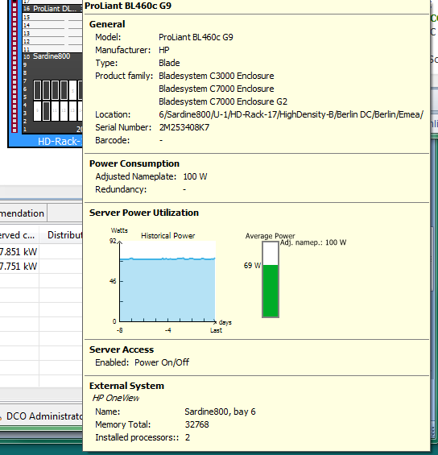

- IT Optimize licensing enables visibility of CPU utilization and Inlet temperature for OneView devices which support monitoring of CPU data and Inlet temp. This information is visible in the IT Optimize overlay displaying the tooltip for a OneView asset.

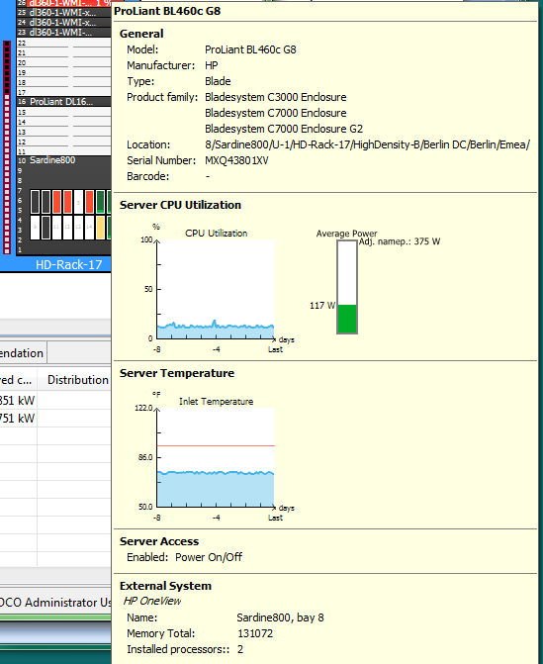

- Server Access licensing enables the ability to launch remote console sessions to the ILO/management card. This option is visible when you right-click on a OneView device which has server access enabled.

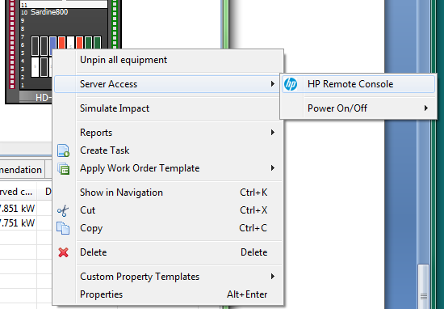
Select “HP Remote Console”. If you have the HP remote console app installed it will be launched automatically.
