In Desktop Client 6 racks belong to 3m with the same Account No 0424058349
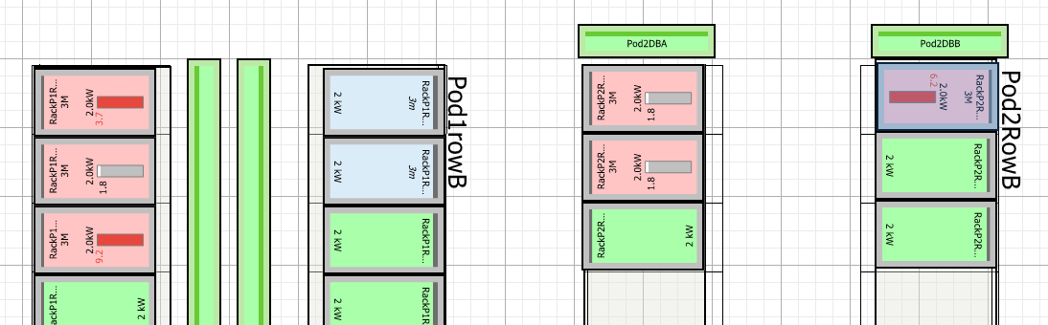
In Web Client as “apc” correctly showing rack names
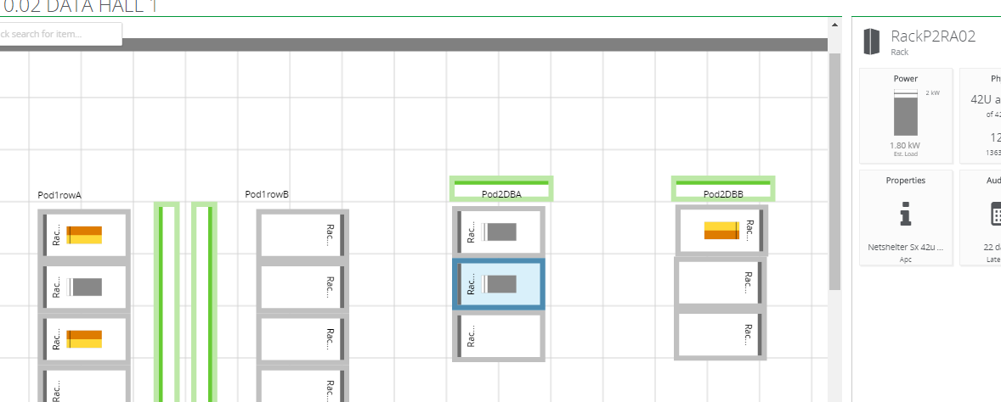
User setup
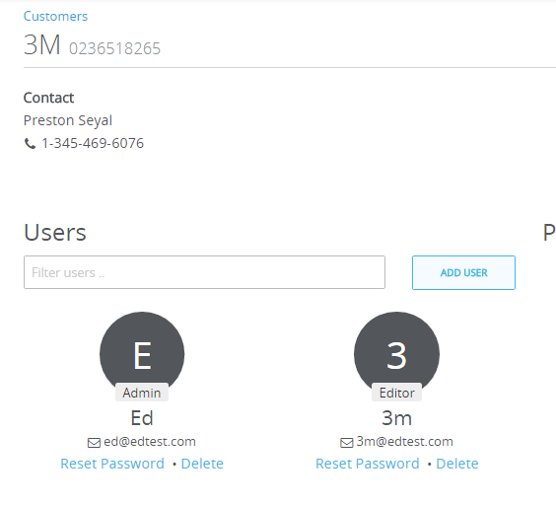

Logged in as ed@edtest.com 4 racks showing and with wrong names
